I B. Tech. II Semester Regular/Supplementary Examinations – May, 2024
Engineering Mechanics
Time: 150 Min (MECH/R&A) Max. Marks: 80M

SECTION – A
Answer all Four questions 4×10M=40M

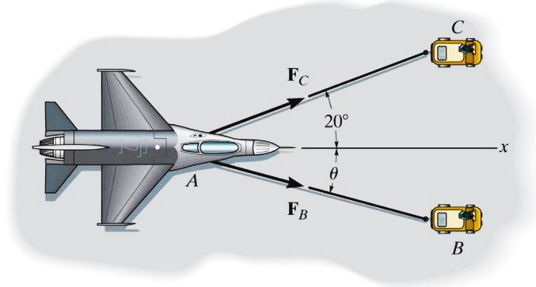
- A disabled aircraft is pulled by two small trucks in x direction with a net force of 105 kN as shown in Fig.1. When θ = 15°,
- Name the fundamental law of mechanics can be used to find F_{B}?
- Which truck exerted more force? Justify your answer.
- Determine the magnitude of smaller force.
Fig. 1
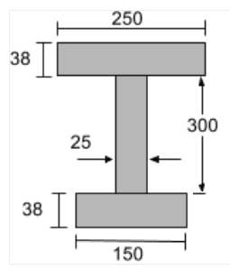
- An I-beam section, shown in Fig. 2, is designed to reduce the deflection of the beam.
- Is the section symmetric about horizontal centroidal axis? Justify your answer
- Assuming all dimensions are in mm, locate the centroid of the section.
- Determine the moment of inertia of the section about any centroidal axis.

Fig. 2

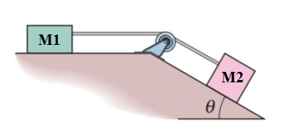
- Two blocks M1 and M2 are connected by a inextensible cable, passed over a frictionless pulley as shown in Fig.3. The masses of M1 and M2 are 42 kg and 36 kg respectively.
- If block M2 has an impending motion, what is the tension on cable? Fig. 3
Take μ at M1 is 0.2 and the same at M2 is 0.32.
- Estimate the minimum angle θ, for which M2 will have impending motion.
- With the estimated angle θ (b), if there is no friction between block M2 and inclined plane, determine the tension on cable.

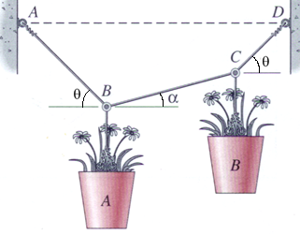
- Two flowerpots are supported with three steel wires of equal diameter as shown in Fig.4. Pot A weighs 150 N and θ = 45°.
- Tension on wires AB and CD will be always equal as the inclinations are equal - True or false?
- If α = 15°, estimate the weight of pot B.
- With the estimated weight of pot B (b), determine the tensions all three steel wires.
Fig. 4

SECTION - B
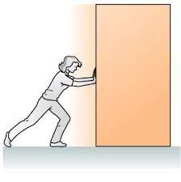
Answer all Two questions 2×20M=40M
- A wardrobe of weight 450 N, resting on a horizontal plane, is pushed towards right as shown in Fig.5(i). If the coefficient of friction between all contacting surfaces is 0.3
- Determine the minimum horizontal force required to push the wardrobe.
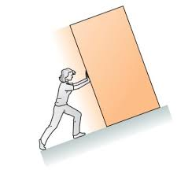
- Estimate the reaction and friction forces at the foot of the person if the person weighs 700 N.
Fig. 5 (i)

- If the same wardrobe is pushed along an inclined plane as shown in Fig. 5 (ii), required force will be more or less in comparison with (a)? Justify your answer.

Fig. 5 (ii)

- A Pratt truss is used to support the roof of a seminar hall and loaded as shown in Fig. 6.
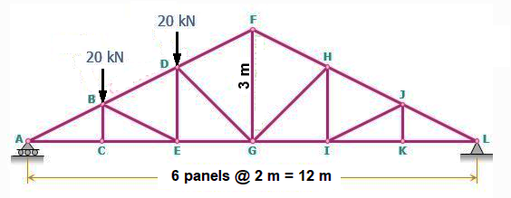
Fig. 6
- Check whether the truss is ‘perfect truss’ or not? If not, name the type. Also Find the reaction forces at the supports.
- Estimate the force on the members DF, DG and EG of the truss.
- State the methodology to find the forces on members IJ and JK.

